**CS691 - Computer Science, Fall 2018**

**Project Initiation Document**

Project: Food for Thought

Project Manager: Emily Erb

Start Date: September 10, 2018

Completion Date:

Table of Contents

Document Purpose 4

Background to the Proposed Work 4

Vision 4

Project Objectives 4

Project Scope 4

Business Case 5

Assumptions 5

Constraints 5

Risk Management Strategy 5

Deliverables 6

Stakeholders 6

Project Team 6

Project Plan 7

Project Controls 7

Communication Plan 7

Document Details

|  |  |  |  |
| --- | --- | --- | --- |
| Version | Modifications | Author | Date |
| 1 | Initial PID Document | PM | 09/26/2018 |
| 2 | Refined PID Document with Initial Project Plan | PM | 10/08/2018 |
|  |  |  |  |
|  |  |  |  |

Approvals

This document requires the following approvals:

|  |  |  |  |  |
| --- | --- | --- | --- | --- |
| Name | Role | Signature | Date | Version |
| Emily Erb | Project Manager |  | 09/26/2018 |  |
|  | Product Owner |  | 09/26/2018 |  |
|  | Lead Business Analyst |  | 09/26/2018 |  |
|  | Lead Developer |  | 09/26/2018 |  |
|  | DBA |  | 09/26/2018 |  |
|  | Lead QA Analyst |  | 09/26/2018 |  |

Distribution

This document has been distributed to:

|  |  |  |  |
| --- | --- | --- | --- |
| Name | Role | Date of Issue | Version |
|  |  |  |  |
|  |  |  |  |
|  |  |  |  |
|  |  |  |  |
|  |  |  |  |
|  |  |  |  |

# Document Purpose (assigned to Emily)

This document has been created to record the basic information needed to manage the project. The document will describe the scope, objectives, tasks, roles and responsibilities, costs and deliverables related to Food for Thought Web Application.

The PID dictates the following critical aspects:

· Details of the approach to be adopted for the implementation of the Food for Thought Web Application Project.

· Details of the roles and responsibilities.

· Description of functions and activities.

· Explanation of the processes.

· Details of the communication plan between team members and with the stakeholders.

· Quality records, risks, project controls and exceptions.

The sections of this document are dynamic and could potentially change over the lifetime of the project. The changes will be recorded in the PID document. The PID will be referred each time when a major decision is taken about the project. Also, the PID document will be used at the end of the project to measure whether the project was managed successfully or not and weather all deliverables were produced in timely manner or not.

# Background to the Proposed Work (assigned to Emily)

Most individuals and families have a difficult time deciding what to make for meals and finding the time to go grocery shopping for items that are lacking in their pantry. This forces many to have to order out or turn to fast-food for their meals. This can ultimately lead to excessive and unnecessary spending of money.

The purpose of the project needs to be delivered is to make it simpler for users, i.e. stay-at-home-moms/dads, families, fitness enthusiast, busy individuals, and so on, to plan meals including grocery shopping, as well as expand their food variety. With the system we will be developing, users can use it with ease whatever convenient for them to obtain recipes and shop their local grocery stores.

Through “FoodForThought.com” website we present a comprehensive solution for meal planning. This powerful website is specifically designed for users to quickly and effectively plan their meals. This intuitive visual interface makes day-to-day food planning and shopping reduced to a timely fashion and easy for the user. Furthermore, having easy access to our website will allow individuals and families to save money.

# Vision (assigned to Yuan)

We believe as such an important daily activity, grocery shopping and cooking deserve to be a more efficient, pleasant and easier experience for everyone. By simply adding items to the grocery shopping list online, and set filters, users will have access to customized recipes and have groceries delivery options. Our product will not only solve one-case-problem of grocery shopping and cooking, but to create a new way of healthy and simply lifestyle for everyone.

# Project Objectives (assigned to Yuan)

* To create a website including the functionalities of organizing grocery shopping list, generating recipes based on users input and following grocery delivery services
* To create a user-friendly interface
* To add variety to users’ cooking options
* To promote healthier and easier lifestyle
* To partner with grocery delivery services and food networks and to generate website profit

# Project Scope (assigned to Yang)

Our website offering a platform for users to create meals, recipes and grocery lists according to their needs. The features include:

o User register and login function

o Food search function

o Various recipes generation by users’ preference

o Help users to search the nearest supermarket and order the delivery service

o Security payment process

For the team, we will

o Analyze Mealboard.com and Mealime application to improve the features

o Apply the best UX/UI practices

o Use the completed and reliable database

o Install the required software

o Ensure all team members have necessary skills

o Cooperate on the program development

# Business Case (assigned to Yang)

|  |  |  |
| --- | --- | --- |
| **Application Name** | | Food for Thought |
| **Type of business model** | | Subscription and Advertising Model |
| **Target audience of users** | | Anyone – Families, Stay-at-home moms/dads, fitness |
| **Value proposition** | | Users get access to our website for adding and creating meals, recipes and grocery lists according to their wants and likes. |
| **How the system is used** | Web Application    Within this application, users are able to enter their pantry items, or potential grocery lists in which recipes are generated from these items. Once the ingredients are inputted there are options on the quantity of how many of the ingredients to use to generate the recipe.  The following features are available:  · Categories can be chosen to have a recipe created for a main dish, side, appetizer, etc.  · Filter option for dietary restriction - Vegan, Kosher, Halal, food allergies, etc.  · Filter Option for low calorie, low fat, Keto, high-protein, etc.  **(This feature is limited for Guest Users vs. Subscripted Users)**  Within each user’s personal portal – for those who have a subscription – there is an option for delivery service from local grocery stores. They are able to order cooking ingredients that are missing from the recipes chosen. External systems are integrated here:  · Credit card  · Grocery membership card  (Needs expansion)    A section in the portal will be for international recipes filtered by country, cuisines, etc.    No social networking aspect! | |
| **Revenue generation** | | · Ads  · Monthly Subscriptions |
| **Partners/Suppliers**  **(Stakeholders)** | | · Supermarkets  · Credit card Vendors  · Food Network© |
| **Expected Benefits** | | · To provide anytime and anywhere services to families, individuals and anyone wanting to manage their meals, recipes and/or pantry  · Cut down the time spent planning meals and groceries  · People looking to expand food variety |
| **Known Prototypes** | | Mealboard.com or Mealime Mobile App |

# 

# Assumptions (assigned to Yang)

|  |  |  |  |
| --- | --- | --- | --- |
| Assumption | Validated by | Status | Comments |
| Meeting | Product Manager | In Process | Product manager will schedule one – two meetings every week |
| Team Work | Product Manager | In Process | Product manager will assign works to all team members |
| Skill Requirement | All Members | In Process | All members should cooperate on the programing works |
| Suppliers’ Support | Product Owner | In Process | Owner needs to make sure the support from supermarkets for the food supply and delivery service |

# Constraints (assigned to Reuben)

The things that need to be taken into consideration during the delivery of this project are

* Time: As this is a team project, there are multiple people with different schedules and different levels of time available. Each person has to plan within their own schedule to find time to do individual work for this project and additionally, as a team, we have to work around everyone’s schedule to find time to meet that works for everyone.
* Missing Group Member: Our lead developer has left the group to take a different course so we are one person short, particularly someone with valuable coding experience. We must therefore all take a share of this person’s work so that the burden is not all left on one person to complete that of two people.
* Deadlines: Despite limited time as stated above, the deadlines for each deliverable must be met.
* Requirements: We have to make sure that the application that we develop fulfills the requirements that have been set for this project.

# Risk Management Strategy (assigned to Reuben)

|  |  |  |  |
| --- | --- | --- | --- |
| Risk | Probability | Impact | Mitigation Method |
| Departure of teammate | High | High | All team members should get familiar with other members’ activities to be able to replace them in case of departure. |
| Lack of development skills | Medium | High | All team members should start to practice development skills at early stage of the project. |
| Project takes more time to finish than planned | Medium | Medium | Being organized with project plan. Finish each activity before deadline. If there is extra time, move to the next step as soon as possible. |

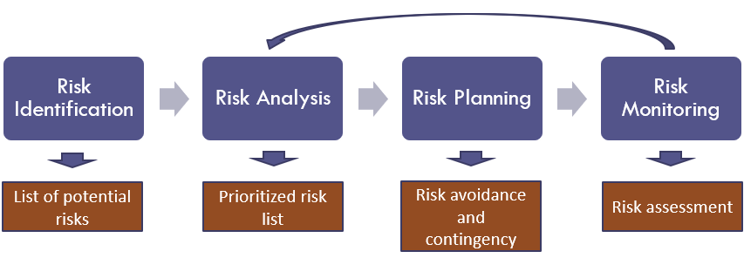*.*

# Deliverables (assigned to Emily)

The deliverables of the project for phase 1 are:

|  |  |  |
| --- | --- | --- |
| **No** | **Artifact Name** | **Responsible Party** |
| **1** | Project Plan | PM |
| **2** | PID document | PM |
| **3** | BRM Diagram | Product Owner |
| **4** | Context Diagram | Lead BA |
| **5** | Architecture Diagrams (2) | Lead Dev/DBA |
| **6** | User Requirements | Product Owner |
| **7** | RCT (includes func. decomp., supplementary reqs) | Lead BA |
| **8** | Use-Case Diagram (UML) | Lead BA |
| **9** | Activity Diagram (UML) | Lead BA |
| **10** | Data-flow Diagram | Lead BA |
| **11** | Functional Requirements (user stories) | Lead BA |
| **12** | Class Diagram (UML) | Lead Dev |
| **13** | Sequence Diagram (UML) | Lead Dev |
| **14** | ER Diagrams (conceptual, logical) | DBA |
| **15** | Table Specs | DBA |
| **16** | Source code sample (part of Application Demo) | Lead Dev |
| **17** | Test Plan document | Lead QA |
| **18** | Application Demo | All |

# Stakeholders (assigned to Dalem)

This section will include a list of all known stakeholders and their interests in the project. It may be presented in the following format:

|  |  |
| --- | --- |
| Stakeholder | Interest |
| Banking/CC Companies | Providing payment options, user subscriptions |
| Local Grocery Stores | Grocery delivery for paid users, business exposure |
| Food Network | Brand name attachment, recipe provider |
|  |  |

# Project Team (assigned to Reuben)

The project team includes the following roles

* Project Manager
* Product Owner
* Lead Developer
* Business Analyst
* QA Lead
* DBA

|  |  |  |  |  |  |  |  |
| --- | --- | --- | --- | --- | --- | --- | --- |
|  |  | **Project Roles** | | | | | |
| **Process Area** | **Project Tasks** | Project Manager | Product Owner | Dev Lead | Business Analyst | Test Manager | DBA |
| Project Management | Develop a project plan | A,R | C | C | C | C | I |
| Provide cost estimate | A,R | C | C | C | C | I |
| Hire resources | A,R | C | C | C | C | I |
| Establish a project portal on SharePoint | A,R | R | I | I | I | I |
| Maintain a project risk and issue log | A,R | R | C | C | C | I |
| Provide project status reports | A,R | R | C | C | C | C |
| Requirements | Perform requirements analysts | A | R | C | R | I | I |
| Gather business requirements | R | I | C | R | I | I |
| Produce functional requirements | A | I | C | R | C | I |
| Design | Produce high-level design specs | A | I | R | C | I | C |
| Produce data model | A | I | C | C | I | R |
| Produce detailed design specs | A | I | R | C | I | R |
| Coding | Establish a code repository | A | I | R | I | I | I |
| Develop component code | A | I | R | I | I | I |
| Testing | Develop a test plan | A | I | C | C | R | C |
| Establish a test repository | A | I | C | I | R | I |
| Develop test specifications | A | I | C | I | R | I |
| Execute testing, report defects | A | I | I | I | R | I |
| Conduct defect review calls | A | I | C | R | R | C |
| Produce, deliver defect metrics | A | I | C | R | R | I |
| Support test environments | A | I | R | C | C | R |
| Deployment | Produce a deployment plan | A | I | R | I | I | R |
| Produce deployment procedures | A | I | R | I | I | R |
| Deploy software into production | A | I | R | C | C | R |

# Project Plan (assigned to Emily)

This semester (Project I), the project will follow the Waterfall model comprised on the phases shown below. The implementation phase is scheduled for 2 weeks where the project team will implement the Home page and login features, laying grounds for the next semester.

The project plan includes 5 milestones defined below.

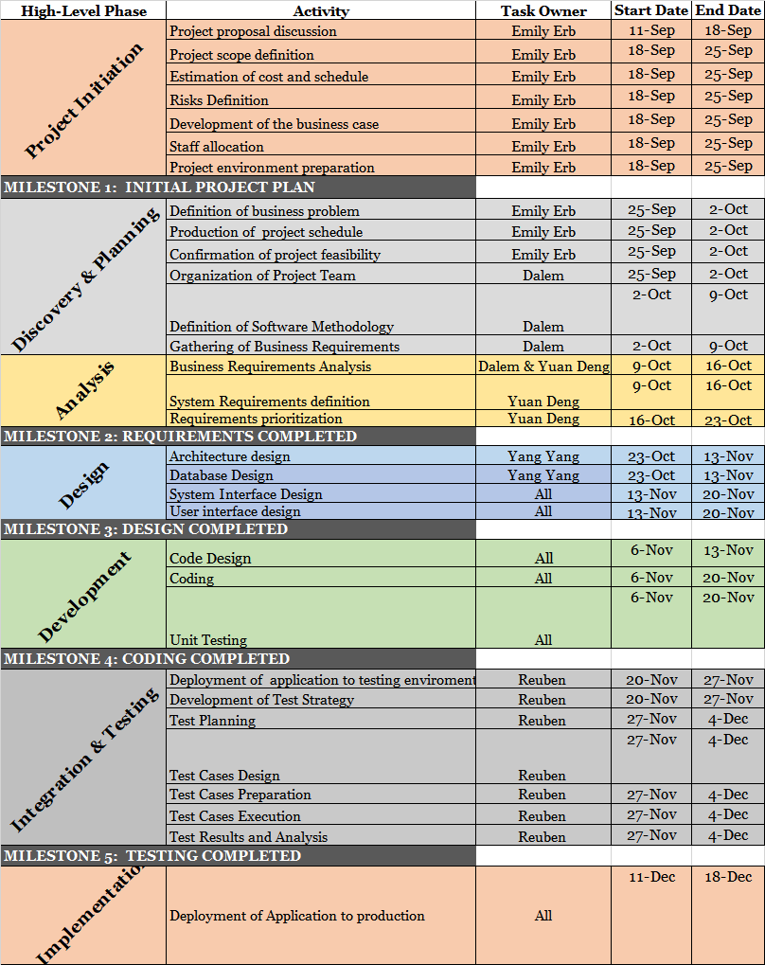

Milestones:

MS1: Initial Project Plan (10/09/2018)

MS2: Requirements Completed (10/30/2018)

MS3: Design Completed (11/20/2018)

MS4: Coding Completed (11/27/2018)

MS5: Testing Completed (12/04/2018)

# Project Controls (assigned to Dalem)

All project aspects will be maintained in English, including, but not limited to, communications, documents, and source code.

Official meetings will be held at least once a week, either in person or through remote video conferencing, in order to discuss progress, delegate tasks, and actively collaborate on project assets. Methods of communication include Zoom for video conferencing, text by phone among team members, and Slack for team and professor communication.

Project documents will be kept and shared using Google G Suite productivity tools for remote access and ease of editing.

# Communication Plan (assigned to Emily)

This section will include how stakeholders will be communicated with during the project and how frequently. This should include a note on where to find the Communications Plan if you have one.

|  |  |  |  |
| --- | --- | --- | --- |
| Stakeholder | Frequency | Type | Purpose |
| Professor | At key stages - meetings and deliverable drafts | Email/Slack | To approve Project implementation and direction. Advise if there are any potential issues. |
| Banking/CC Companies | At key stages | Email, phone, personal meetings | Unknown |
| Local Grocery Stores | At key stages | Email, phone, personal meetings | Unknown |
| Food Network | At key stages | Email, phone, personal meetings | Unknown |
| Project Team | Daily | Email, Voom for business, personal meetings, Slack | Maintain progress and ensure that the team is meeting weekly requirements. |
| End Users | Potentially during the testing phase and after release. | Email, online testing sessions, attend workshops for website | Feedback! |